DriverPass System Design Document

UML Diagrams

UML Use Case Diagram
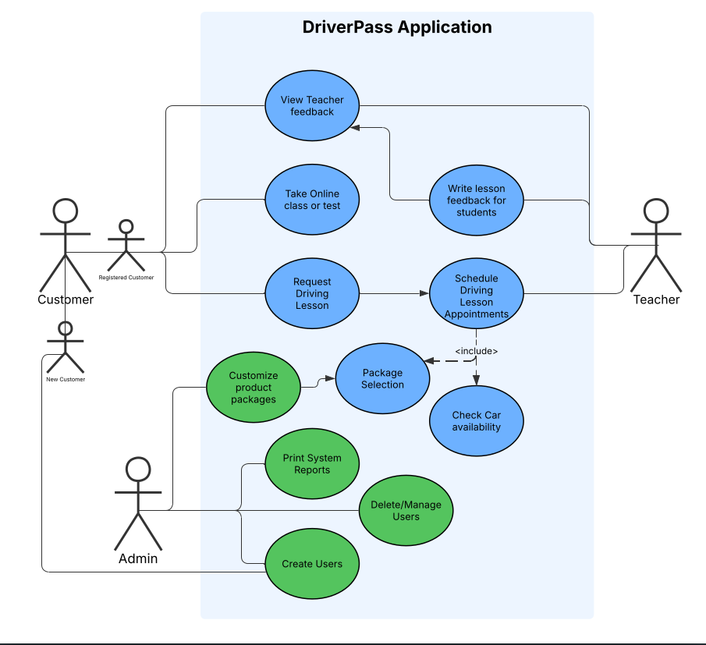

UML Activity Diagrams

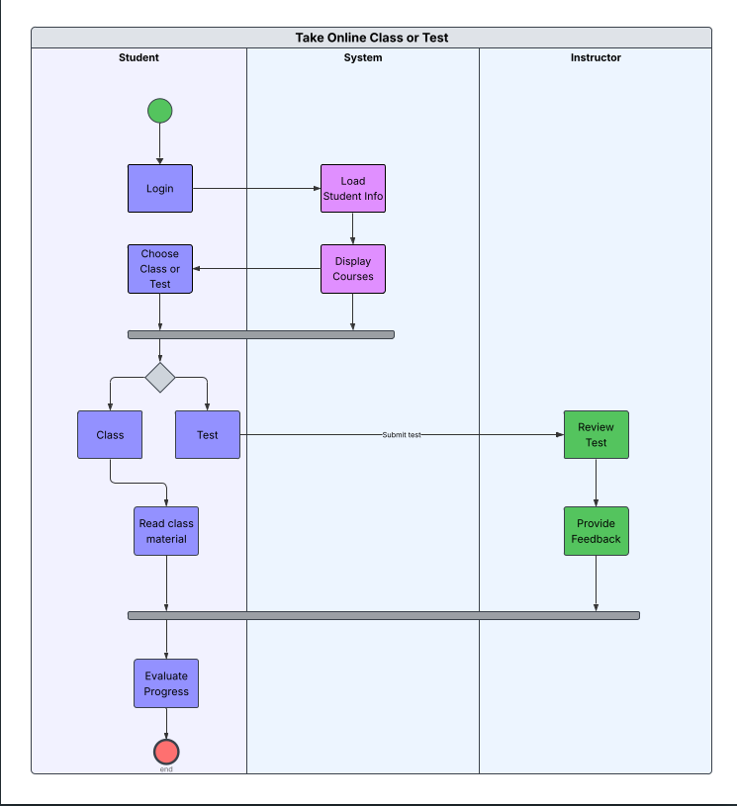

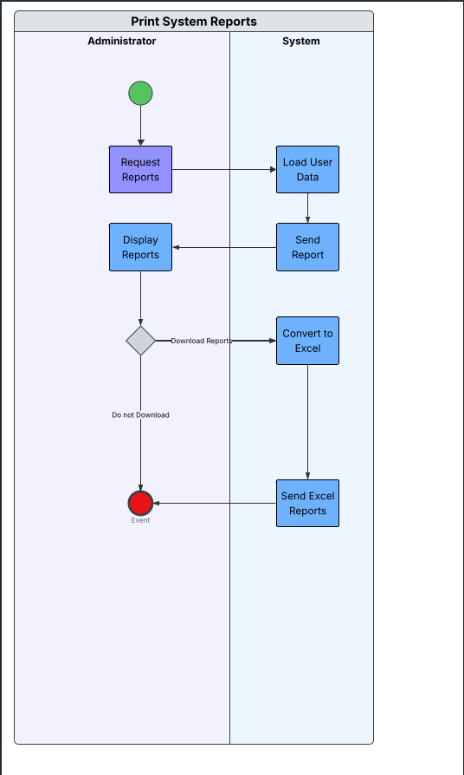

UML Sequence Diagram
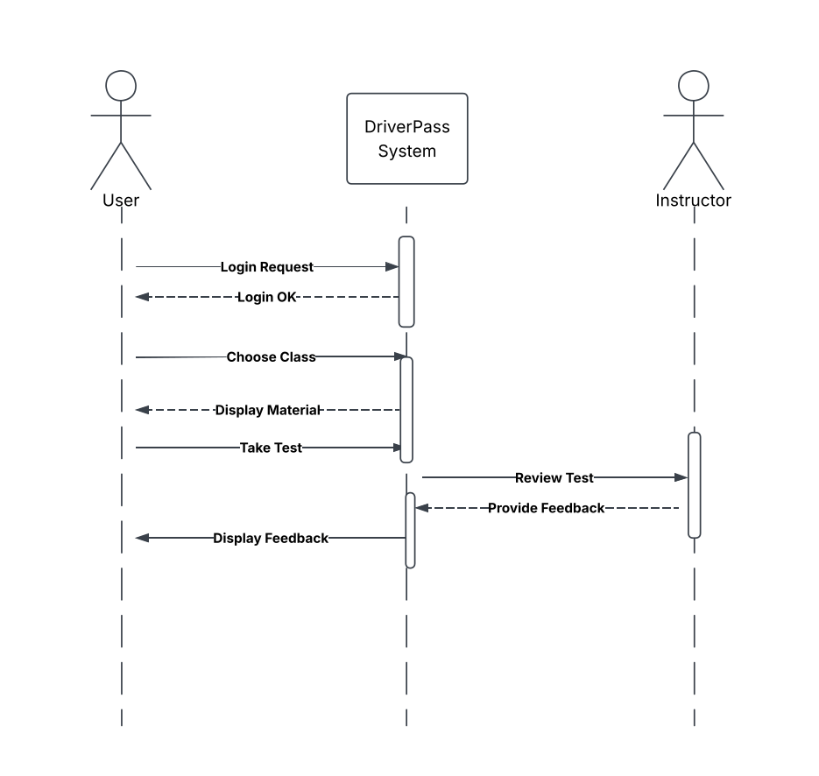

UML Class Diagram
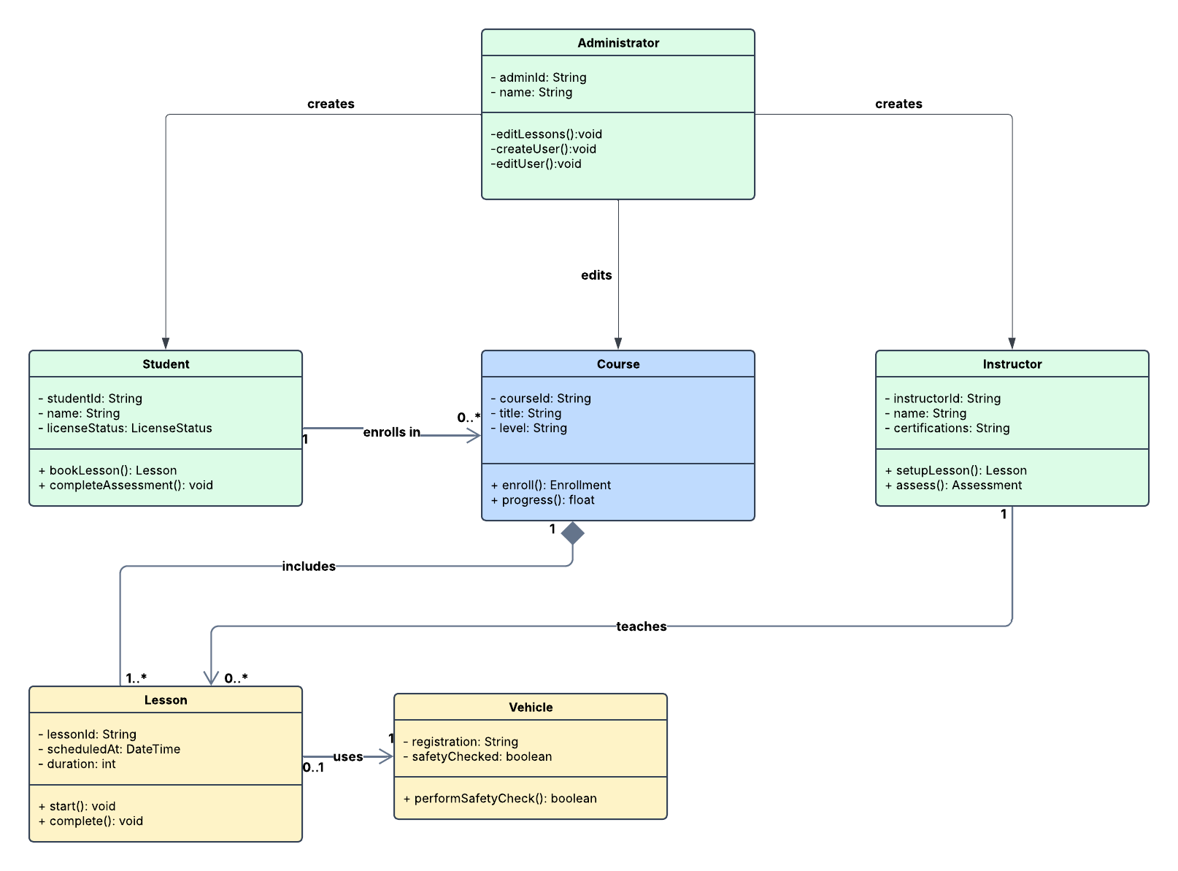

Technical Requirements

- Host user data on an online database that can be accessed remotely by users and DrivePass staff.
- Download of reports and statistics data in Excel format.
- Track changes made by users to the database. Sync data across multiple clients at once.
- The database will include details for company drivers, their assigned cars, and the schedule for each appointment time for all drivers. Information about the customer will be stored as well.
- Administrators in the company will be able to modify user details and reset passwords for users.
- The storage for the database will be cloud based instead of locally hosted, security for assets will be managed by the development team as maintenance.
- Online database that hosts user data, this data is updated for all online members perpetually if connection is available.
- Generates reports compatible with Microsoft Excel.
- Application working on all major PC and mobile operating systems.
- System is not hosted locally, but on the cloud.
- Backups and Security will be handled by cloud service interface, Maintenance will be conducted partially by us and partially by DriverPass IT staff.
- Windows, Mac, Linux, Android, iOS, BSD and UNIX, are all valid OS choices, the browser must meet modern security standards like OWASP and W3C in order to gain access.

